\*Part 1 & 2 pasted as pictures to avoid changing of data when filtering\*

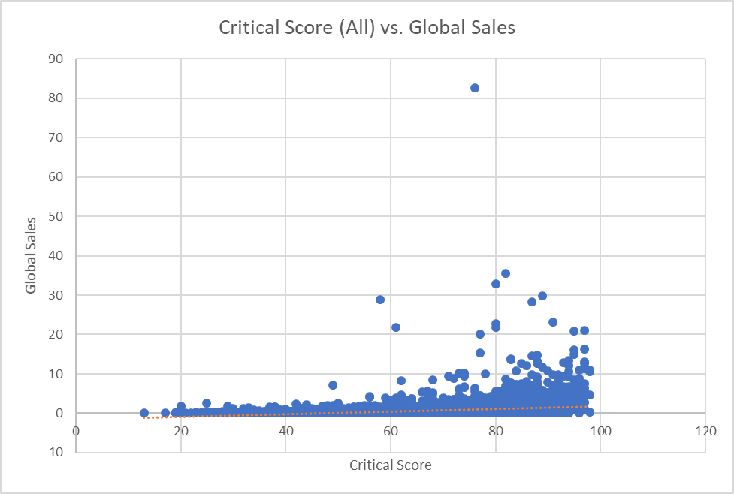Part 1

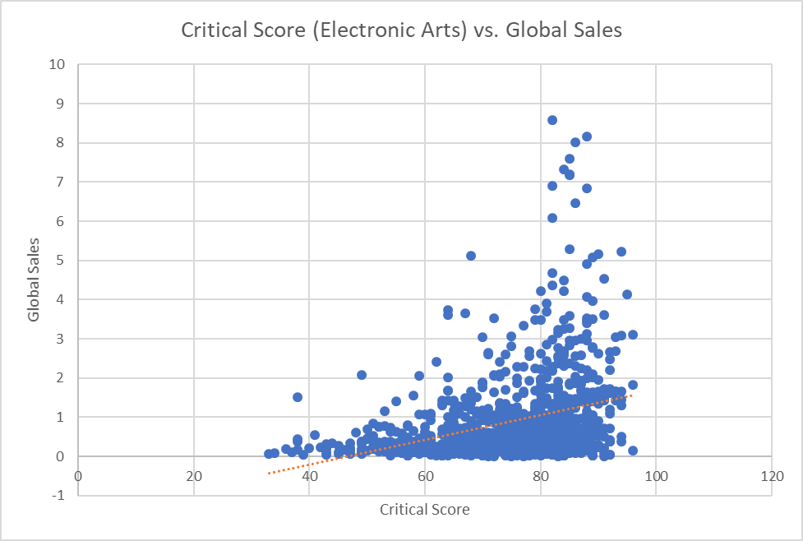Part 2

Part 3